*Insanity is doing the same thing over and over again and expecting different results.*

(Albert Einstein)

*Written by* ***James Cavanaugh***

*11/2010*

Analysis, Design, Development, Implementation, and Evaluation (ADDIE) Approach to Instructional Design is [Apocryphal](http://dictionary.reference.com/browse/Apocryphal)

**Executive Summary**

The intent of this document is to understand the authorship, authenticity, and historical perspective of ADDIE:

* **Authorship:** There are no authors that can be referenced.
* **Authenticity:** There are no Military, Academic or Business organizations that can be referenced.
* **History:** There are no records of origin that can be referenced.

There is no authoritative source, and it appears ADDIE is a label rather than a model.

*I am satisfied at this point to conclude that the ADDIE Model is merely a colloquial term used to describe a systematic approach to instructional development, virtually synonymous with instructional systems development (ISD). The label seems not to have a single author, but rather to have evolved informally through oral tradition. There is no original, fully elaborated model, just an umbrella term that refers to a family of models that share a common underlying structure.* Reference: [In Search of the Elusive ADDIE Model](http://www.indiana.edu/~molpage/In%20Search%20of%20Elusive%20ADDIE.pdf#search=%22ADDIE%20Model%20%2Bhistory%22)

We know the private and public sectors build training based upon ADDIE. In reality, decision-makers, training managers, and project leads are most likely not concerned that a body of research for ADDIE does not exist. It is a 35 years urban legend that is automatically accepted as an industry standard.

***Example:***

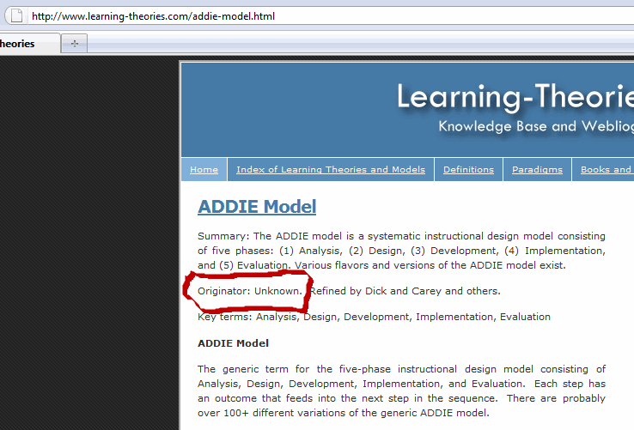

**References**

* Andrews, D. H., & Goodson, L. A. (1980). A comparative analysis of models of instructional design. *Journal of Instructional Development,* 3:4, 2-16.
* Branson, R. K. (1978). The inter-service procedures for instructional systems development. *Educational Technology*, March, 11-14.
* Briggs, L. J. (1970). *Handbook of procedures for the design of instruction*. Pittsburgh: American Institutes for Research.
* Clark, D. (1995). *Big Dog’s ISD Page.* Available at http://www.nwlink.com/~donclark/hrd/sat1.html#model. Retrieved December 9, 2002.
* Dick, W., Carey, L. & Carey, J. O. (2001). *The systematic design of instruction*, 5th Ed. New York: Longman.
* Gentry, C. G. (1994). *Introduction to instructional development*. Belmont: Wadsworth.
* Grafinger, Deborah J. (1988). *Basics of instructional systems development*. INFO-LINE Issue 8803.
* Alexandria: American Society for Training and Development.
* Gustafson, K. L. (1994). Instructional design models. In Husen, T. & Postlethwaite, T.N. (ed’s) *The International Encyclopedia of Education*, 2nd ed. Oxford: UK, Pergamon.
* Gustafson, K. L., & Branch, R. M. (1997). *Survey of instructional development models*. Syracuse: ERIC Clearinghouse on Information & Technology.
* Gustafson, K. L., & Branch, R. M. (2002). What is instructional design? In Reiser, R, A. and Dempsey, J. V. (ed’s) *Trends and Issues in Instructional Design and Technology.* Columbus: OH, Merrill Prentice Hall.
* Heinich, R., Molenda, M., Russell, J. D., & Smaldino, S. (2002). *Instructional media and technologies for learning*, 7th ed. Columbus: Merrill/Prentice Hall.
* Kovalchick, A., & Dawson, K. (in press). *Educational technology: An encyclopedia*. Santa Barbara, CA: ABC-CLIO.
* Molenda, M., Pershing, J. A., & Reigeluth, C. M. (1996). Designing instructional systems. In R. L. Craig (Ed.), *The ASTD training and development handbook* 4th ed. (pp. 266-293). New York: McGraw-Hill.
* Molenda, M., & Pershing, J. A., (2003). *The strategic impact model or “Indiana model.”* Unpublished paper, available from authors. Bloomington: Indiana University.
* Morrison, G. R., Ross, S. M., & Kemp, J. E. (2001). *Designing effective instruction*, 3rd ed. New York: John Wiley.
* Reiser, R. A. 2001. A history of instructional design and technology. In Reiser, R. A. and Dempsey, J. V., ed’s. *Trends and issues in instructional design and technology*. Englewood Cliffs: Prentice Hall College Division.
* Rossett, A. (1987). *Training needs assessment.* Englewood Cliffs: Educational Technology Publications.
* Saettler, P. (1990). *The evolution of American educational technology*. Englewood: Libraries Unlimited.
* Shrock, S. (1995). A brief history of instructional development. In Anglin, Gary (ed.) *Instructional technology: Past, present, and future.* Englewood: Libraries Unlimited.
* Smith, P. L., and Ragan, T. J. (1999). *Instructional design*, 2nd Ed. Columbus: Merrill, Prentice Hall.
* Thiagarajan, S. (1976). Help I am trapped inside an ID model! *NSPI Journal* (November), 10-11.

**My ADDIE Approach**

When called upon to employ ADDIE, I have done so in the following way:

1. **Analysis:**

* Who are the learners and what are their characteristics?
* What is the new behavioral outcome?
* What types of learning constraints exist?
* What are the delivery options?
* What are the online pedagogical considerations?
* What are the Adult Learning Theory considerations?
* What is the timeline for project completion?

1. **Design**

* Document the project's instructional, visual and technical design strategy
* Apply instructional strategies according to the intended behavioral outcomes by domain (cognitive, affective, and psychomotor).
* Design the user interface and/or user experience
* Create prototype
* Apply visual design (graphic design)

1. **Development**

* Instructional designers and developers create and assemble the content assets that were blueprinted in the design phase.
* Storyboards and graphics are designed.
* If e-learning is involved, programmers develop and/or integrate technologies.
* Testers perform debugging procedures.
* The project is reviewed and revised according to the feedback received.

1. **Implementation**

* During the implementation phase, a procedure for training the facilitators and the learners is developed.
* The facilitators' training should cover the course curriculum, learning outcomes, method of delivery, and testing procedures.
* Preparation of the learners includes training them on new tools (software or hardware) and student registration.
* This is also the phase where the project manager ensures that the books, hands-on equipment, tools, CD-ROMs and software are in place, and that the learning application or website is functional.

1. **Evaluation**

* The evaluation phase consists of two parts: formative and summative.
* Formative evaluation is present in each stage of the ADDIE process.
* Summative evaluation consists of tests designed for domain specific criterion-related referenced items and providing opportunities for feedback from the users which were identified.

When called upon to develop training that increases the probability training participants successfully achieve the skills and knowledge they can use in their real-world, I employ Systematic Instructional Systems Design.

**Systematic Instructional Systems Design Alternative**

**Stages of Development**

PRODUCTIVITY GOALS

* **Principle:** If we formulate results outputs (RO) over resources inputs (RI), then we can define the benefits we intend to achieve from the training so that we can specify how much they will cost.
* *Example:*
* Increase production by 20% while decreasing resource expenditures by 5%.
* Reduce resource capital expenditures for materials, methods, equipment, energy, and space.
* Increase market share by 50% while increasing resource expenditures by 10%.
* **Comment:** Training that does not benefit organizations and their member is meaningless. Training initiatives without productivity goals is like building a new ship without navigational gear or a compass.

CONTEXTUAL TASK ANALYSIS

* **Principle:** If we identify work setting tasks which must be performed to accomplish productivity goals, then we can assess the personnel barriers to task performance so that training skill objectives can be defined.
* *Example:*

|  |  |  |  |
| --- | --- | --- | --- |
| **Type of Process Tasks Identified** | | | |
| **Personnel Type** | **Plan** | **Produce** | **Assess** |
| *Production Workers* | * Gather and Assemble Materials * Schedule Activities * Develop Individual Work Plans | * Perform Specific Job Tasks * Transmit Products | * Check Results Outputs * Document Use of Resource Inputs |

* **Comment:** The pursuit of productivity goals requires an analysis of the contextual tasks.

FULLY DEFINED TRAINING SKILL OBJECTIVES

* **Principle:** If the training addresses objectives, then critical tasks can be performed in the working environment so that productivity goals can be reached.
* *Example:*

Who and what things are involved: *Women training participants with battery jumper cables* What are they doing? *will charge a dead car battery* How are they doing it? *by connecting cables from a charged car battery to a dead car battery* When, where, and why are they doing it? *whenever there is a need, in the training garage and real-world so that they can turn over the engine of the car requiring a jump* How well are they doing it? *to the point where they can drive the car to their destination.*

* **Comment:** The removal of contextual barriers requires that specific objectives be established.

TRAINING CONTENT DEVELOPMENT

* **Principle:** If the quality of the training content is high, then it increases the probability of attaining the training objectives so that training participants can advance from their current levels of performance to the desired level of performance.
* *Example:* 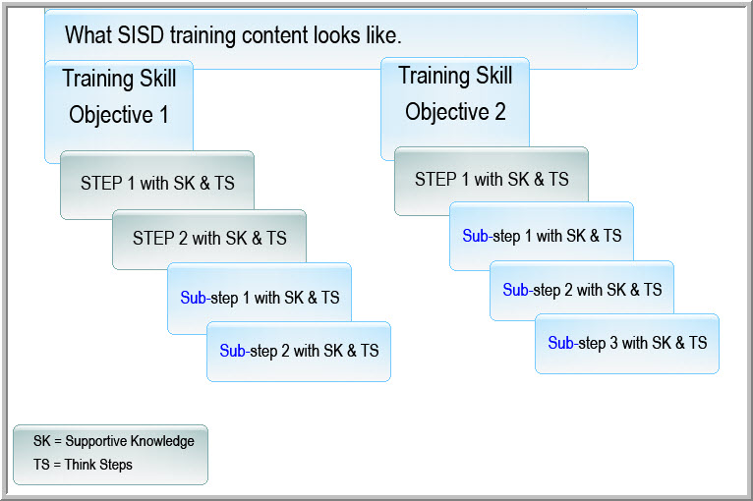
* **Comment:** All steps in the Systematic Instructional Systems Design process are linked to one another. Poor content development results in poor training delivery. Obviously, the information provided by Subject Matter Experts is critical. See Unpublished White Paper, [*The Subject Matter Export Information Problem*](http://idexamples.com/whitepaper.html), Cavanaugh, 2004.

PLANNING TRAINING DELIVERY

* **Principle:** If we plan the training effectively, then we organize the training methods so that we can link the content, the trainees, the instructional technologist, and the training objectives in a systematic yet dynamic fashion.
* *Example:*

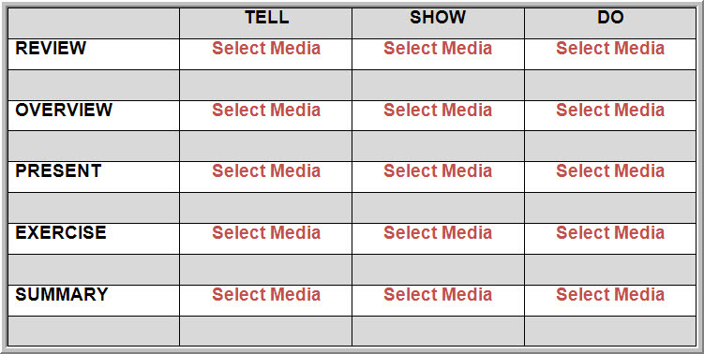

* **Comments:** If content development is like product development, then planning training delivery is like product marketing. Many workers apply their skills acquired in training without ever thinking about them. Some remain unable to make skill application in the work context. These trainees feel frustrated because they cannot perform the skills they should be prepared to do. Sometimes they never learned the skill in the first place – because the training did not plan around the skill application. The fundamental principle is that a delivery plan be organized around a skill application. Learning must be instrumental for the learner’s purposes. If we do not retain the learning in our “permanent memory files” if it is not useful to us.

References:

1. [*Instructional Systems Design – Designing the Instructional System*, Carkhuff and Fisher, 1984.](http://openlibrary.org/works/OL3405583W/Designing_the_instructional_system)
2. [*The Heart of Empathy*](http://www.hrdpress.com/The-Heart-of-Empathy-THOE), Berenson, 2009.
3. [*The Subject Matter Expert Information Problem*](http://idexamples.com/whitepaper.html), Cavanaugh, 2004.

**Implications**

As professionals, the fundamental principle of evaluation is the principle of integrity: If we accomplish our training objectives, then we will have fulfilled our constructive intentions. If our training achieves what we said it would achieve, then we have kept our word. If we have achieved **all** the assessments levels below, then we have done what we said the training would accomplish:

|  |  |  |
| --- | --- | --- |
| **ASSESSMENT LEVELS** | | |
| **5** | **Goal Achievement** | Did the trainees achieve the productivity goals? |
|  |  |  |
| **4** | **Task Transfer** | Did the trainees transfer content to their real-life contextual tasks? |
|  |  |  |
| **3** | **Skill Application** | Did the trainees apply the training content to the training objectives? |
|  |  |  |
| **2** | **Content Acquisition** | Did the trainees acquire the training content? |
|  |  |  |
| **1** | **Process Movement** | Did the trainees act to receive the training content? |
|  |  |  |